**Multidimensional Array**

In this tutorial, we will learn about the multidimensional array in C# using the example of two-dimensional array.

Before we learn about the multidimensional arrays, make sure to know about the [single-dimensional array in C#](https://www.programiz.com/csharp-programming/arrays).

In a multidimensional array, each element of the array is also an array. For example,

int[ , ] x = { { 1, 2 ,3}, { 3, 4, 5 } };

Here, x is a multidimensional array which has two elements: **{1, 2, 3}** and **{3, 4, 5}**. And, each element of the array is also an array with **3** elements.

**Two-dimensional array in C#**

A two-dimensional array consists of single-dimensional arrays as its elements. It can be represented as a table with a specific number of rows and columns.

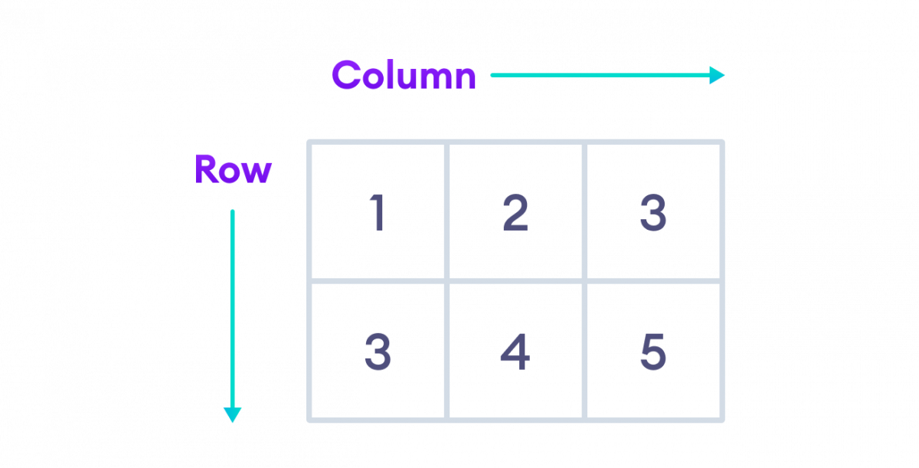C# Two-dimensional array

Here, rows **{1, 2, 3}** and **{3, 4, 5}** are elements of a 2D array.

**1. Two-Dimensional Array Declaration**

Here's how we declare a 2D array in C#.

int[ , ] x = new int [2, 3];

Here, x is a two-dimensional array with **2** elements. And, each element is also an array with **3** elements.

So, all together the array can store **6** elements (**2 * 3**).

Note: The single comma [ , ] represents the array is 2 dimensional.

**2. Two-Dimensional Array initialization**

In C#, we can initialize an array during the declaration. For example,

int[ , ] x = { { 1, 2 ,3}, { 3, 4, 5 } };

int[ , ] x = { { 1, 2, 3}, { 3, 4, 5 } };

Here, x is a 2D array with two elements {1, 2, 3} and {3, 4, 5}. We can see that each element of the array is also an array.

We can also specify the number of rows and columns during the initialization. For example,

int [ , ] x = new int[2, 3]{ {1, 2, 3}, {3, 4, 5} };

**3. Access Elements from 2D Array**

We use the index number to access elements of a 2D array. For example,

// a 2D array

int[ , ] x = { { 1, 2 ,3}, { 3, 4, 5 } };

// access first element from first row

x[0, 0]; // returns 1

// access third element from second row

x[1, 2]; // returns 5

// access third element from first row

x[0, 2]; // returns 3

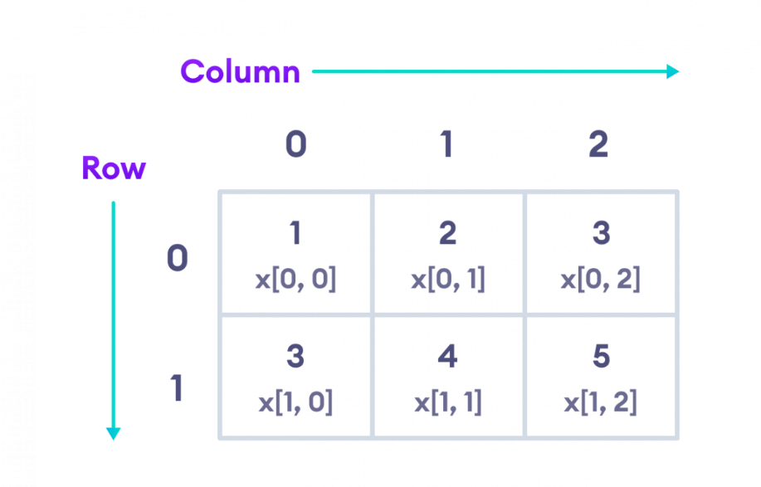

Elements of Two-Dimensional array in C#

**Example: C# 2D Array**

using System;

namespace MultiDArray {

class Program {

static void Main(string[] args) {

//initializing 2D array

int[ , ] numbers = {{2, 3}, {4, 5}};

// access first element from the first row

Console.WriteLine("Element at index [0, 0] : "+numbers[0, 1]);

// access first element from second row

Console.WriteLine("Element at index [1, 0] : "+numbers[1, 1]);

}

}

}

**Output**

Element at index [0, 1] : 3

2 (0,0)

3 (0,1)

4 (1,0)

5 (1,1)

Element at index [1, 1] : 4

In the above example, we have created a 2D array named numbers with rows **{2, 3}** and **{4, 5}**.

Here, we are using the index numbers to access elements of the 2D array.

* numbers[0, 0] - access the first element from the first row (**2**)
* numbers[1, 0] - access the first element from the second row (**4**)

**Change Array Elements**

We can also change the elements of a two-dimensional array. To change the element, we simply assign a new value to that particular index. For example,

using System;

namespace MultiDArray {

class Program {

static void Main(string[] args) {

int[ , ] numbers = {{2, 3}, {4, 5}};

// old element

Console.WriteLine("Old element at index [0, 0] : "+numbers[0, 0]);

// assigning new value

numbers[0, 0] = 222;

// new element

Console.WriteLine("New element at index [0, 0] : "+numbers[0, 0]);

}

}

}

**Output**

Old element at index [0, 0] : 2

New element at index [0, 0] : 222

In the above example, the initial value at index **[0, 0]** is **2**. Notice the line,

// assigning new value

numbers[0, 0] = 222;

Here, we are assigning a new value **222** at index **[0, 0]**. Now, the value at index **[0, 0]** is changed from **2** to **222**.

**Iterating C# Array using Loop**

using System;

namespace MultiDArray {

class Program {

static void Main(string[] args) {

int[,] numbers = { {2, 3, 9}, {4, 5, 9} };

for(int i = 0; i < numbers.GetLength(0); i++) {

Console.Write("Row "+ i+": ");

for(int j = 0; j < numbers.GetLength(1); j++) {

Console.Write(numbers[i, j]+" ");

}

Console.WriteLine();

}

}

}

}

**Output**

Row 0: 2 3 9

Row 1: 4 5 9

In the above example, we have used a [nested for loop](https://www.programiz.com/csharp-programming/nested-loops) to iterate through the elements of a 2D array. Here,

* numbers.GetLength(0) - gives the number of rows in a 2D array
* numbers.GetLength(1) - gives the number of elements in the row

**Note**: We can also create a 3D array. Technically, a 3D array is an array that has multiple two-dimensional arrays as its elements. For example,

int[ , , ] numbers = { { { 1, 3, 5 }, { 2, 4, 6 } },

{ { 2, 4, 9 }, { 5, 7, 11 } } };

Here, [ , , ] (2 commas) denotes the 3D array.